MODERN PORTFOLIO THEORY AND INVESTMENT ANALYSIS
9TH EDITION

ELTON, GRUBER, BROWN, & GOETZMANN

The following exam questions are organized according to the text's sections. Within each section, questions follow the order of the text's chapters and are organized as multiple choice, true-false with discussion, problems, and essays. The correct answers and the corresponding chapter(s) are indicated below each question.

PART 3: MODELS OF EQUILIBRIUM IN THE CAPITAL MARKETS

Multiple Choice

1. The CAPM implies that:
a. investors may invest in assets with expected returns lower than the riskless interest rate.
b. no investor should invest in the risk-free asset.
c. the only relevant measure of risk is standard deviation.
d. the expected return on an efficient portfolio may be lower than the riskless interest rate.
Answer: A
Chapter: 13

2. The beta of an efficient portfolio:
a. must be 1 since an efficient portfolio is perfectly positively correlated with the market portfolio.
b. is proportional to 1, depending on the proportion invested in the market portfolio.
c. is equivalent to the portfolio's standard deviation, since standard deviation is the measure of risk for an efficient portfolio.
d. is always less than 1.
Answer: B
Chapter: 13

3. Assume that the risk-free rate is 9% and that the market portfolio has an expected return of 17%. Under equilibrium conditions as described by the CAPM, what would be the expected return for a portfolio having no diversifiable risk and a beta of 0.75?
a. 17%
b. 9%
c. 20%
d. 15%
Answer: D
Chapter: 13

4. Assume that the risk-free rate is 9% and that the market portfolio has an expected return of 17%. What expected return would be consistent with the CAPM for a security with a beta of 1.5?
a. 13%
b. 21%
c. 25.5%
d. 17%
Answer: B
Chapter: 13

5. Which statement of the following statements is true?
a. In equilibrium, every security and combination of securities lies on the Capital Market Line.
b. In equilibrium, every security and combination of securities lies on the Security Market Line.
c. Only efficient portfolios lie on the Security Market Line.
d. In equilibrium, every security and combination of securities lies lower than the Capital Market Line.
Answer: B
Chapter: 13

6. Security A has a greater level of systematic risk than security B. The expected equilibrium return for A must be greater than that for B because:
a. B's price will fall as investors realize that B offers lower returns.
b. if it is not, then A's price will fall and B's price will rise as investors sell A and buy B.
c. the Security Market Line is negatively sloped.
d. the standard deviation of A's return is greater than B's.
Answer: B
Chapter: 13

7. If the standard CAPM holds, a security with a high variance of return and a beta of zero should be expected to earn:
a. a zero rate of return.
b. the market rate of return.
c. the risk-free rate of return.
d. higher rate of return
Answer: C
Chapter: 13

8. The existence of riskless lending and borrowing at the same rate and homogeneous expectations means:
a. all investors hold the same portfolio of risky assets.
b. all investors will either borrow or lend.
c. all investors place at least some of their wealth in the riskless asset.
d. none of the above.
Answer: A
Chapter: 13

9. The standard CAPM implies:
a. investors are compensated for all risk they take.
b. investors are compensated for all market risk they take.
c. portfolio diversification does not matter.
d. high-return investments have higher variances than low-return investments.
Answer: B
Chapter: 13

For the following three questions, assume that: 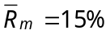, 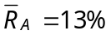, 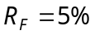, 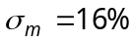, the market portfolio is a tangency portfolio, and that A is an efficient portfolio on the Capital Market Line.

10. What is the standard deviation of portfolio A?
a. 12.8%
b. 13.8%
c. 10.7%
d. 28.6%
Answer: A
Chapter: 13

11. What would be the expected rate of return of portfolio A if its standard deviation was 32%?
a. 25%
b. 15%
c. 30%
d. 20%
Answer: A
Chapter: 13

12. What would be the expected return and standard deviation of a portfolio with equal proportions invested in Treasury bills and the market portfolio?
a. 7.5%, 8%
b. 10%, 8%
c. 10%, 16%
d. 25%, 32%
Answer: B
Chapter: 13

13. Which statement of the following statements is true?
a. All portfolios that plot on the Security Market Line are efficient.
b. All portfolios that plot on the Security Market Line are inefficient.
c. Both efficient and inefficient portfolios plot on the Capital Market Line.
d. Only individual securities plot on the Capital Market Line.
Answer: A
Chapter: 13

14. In a CAPM framework, prohibiting short sales:
a. will prohibit investors from holding the market portfolio in equilibrium.
b. will make the security market line steeper.
c. will encourage investors to hold more riskless assets.
d. will not change the equilibrium.
Answer: D
Chapter: 14

15. In case of a simple CAPM being used to estimate a time series data:
a. the mean of a residual risk should be equal to zero.
b. the regression coefficient should be equal to zero.
c. the difference between the market return and the riskfree rate of return should be equal to zero.
d. the beta of the portfolio should be equal to zero.
Answer: B
Chapter: 15

16. A long-short investment strategy is used in the case where the target is being tracked vastly differs from a diversified market portfolio. In such a situation, a _____ model is being used.
a. multi-index
b. single-index
c. multi-asset pricing
d. value at risk
Answer: A
Chapter: 16

17. What is the expected return on asset A if it has a beta of 0.6, the expected market portfolio return is 15%, and the risk-free rate is 6%?
a. 12.4%
b. 11.4%
c. 11.8%
d. 10.2%

Answer: B
Chapter 13

True-False

1. Assume that the assumptions underlying the standard CAPM hold. Indicate whether each of the following statements is true or false.
a. A firm with a high variance will have a higher beta than a firm with a low variance.
b. A portfolio is efficient if it has no unsystematic risk.
c. A firm that is highly correlated with the market will have a higher beta than a firm that is less correlated.
d. If the variance of the market portfolio goes up, the betas of all securities will go down.
e. A well-managed firm will have a lower beta than a poorly managed firm.
f. The market portfolio is efficient. Therefore, it contains only the best stocks in the market.
g. A risk-seeking investor should hold the riskiest stocks in the market, and a risk-averse investor should hold the safest stocks.
h. If the riskless rate increases, the slope of the capital market line will decrease.
Answer:

a. False
b. True
c. False
d. False
e. False
f. False
g. False
h. True
Chapter: 13

True-False With Discussion

1. Discuss whether the following statement is true or false:
If there were no riskless assets in the economy, then there would be no security market line.
Answer: False
The security market line describes the expected return for all assets and portfolios in the economy. The expected return of an asset or a portfolio, whether efficient or not, can be determined.

In a situation, where there is no lending or borrowing of riskfree securities, the security market line will still hold existence. Here, the straight line will be described by any two points. One convenient point is the market portfolio. A second convenient portfolio is where the straight line cuts the vertical axis (where Beta equals zero).

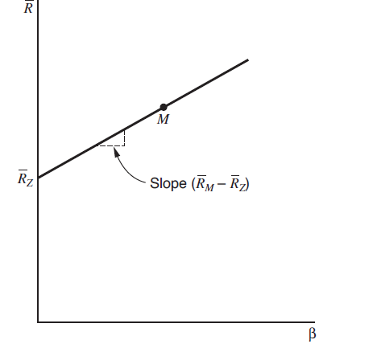
The equation of the straight line will be 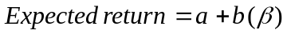 and will hold for a portfolio with zero Beta. 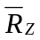 will be the expected return on this portfolio. Solving the equation further, we will get the final equation for the expected return on any security or portfolio as 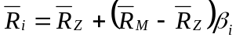.
Chapter: 14

2. Discuss whether the following statement is true or false:
Under the assumption of the standard CAPM, an investor who is very risk averse will only invest in the riskless asset and risky assets with very low variances.
Answer: True
Low-beta stocks are a result of low standard deviation, which means a low risk of non performance of an asset. Low risk of an asset gives lower returns on the asset due to the linear correlation between a security or portfolio’s returns and Beta. Hence, an investor who wishes to minimize default risk and is ready to get lower returns on his portfolio, should predominantly buy low variance stocks.
Chapter: 13

3. Discuss whether the following statement is true or false:
If the post-tax form of the CAPM holds, then a tax-free institution should hold the market portfolio.
Answer: True
If returns are determined by the equilibrium model as shown in the equation , it should be possible to derive optimal portfolios for any investor as a function of the tax rates paid on capital gains and dividends. Individuals hold widely diversified portfolios that resemble the market portfolio. However, since tax-free institutions have a competitive advantage when they hold dividend stocks, their portfolios will resemble the market portfolio but will be tilted in favor of dividends stocks.
Chapter: 14

4. Discuss whether the following statement is true or false:
Under the assumption of a CAPM with no riskless lending or borrowing, every investor holds the same portfolio of risky assets.
Answer: True
In a situation where there is no riskless lending or borrowing, and all investors have homogeneous expectations, they must all face the same efficient frontier. In equilibrium, if securities or portfolios happened to lie on a straight line in expected return Beta space, all combinations of securities or portfolios would lie on the same line. Hence, all investors will hold the same portfolio of risky assets.
Chapter: 14

5. Discuss whether the following statement is true or false:
A very risk-averse investor should buy predominantly low-beta stocks.
Answer: False
A very risk-averse investor will buy low-beta stocks as well as stocks which are risk free in nature. It is always desired to have a portfolio which is diversified and not leaning on either of the sides.
Chapter: 13

6. Discuss whether the following statement is true or false:
It is possible for a stock to have an expected rate of return that is negative.
Answer: True
In a situation where the Beta of a stock is negative, it means that the market and the stock prices are having a negative correlation. This implies that when the markets rate increases, the stock rate moves down leading to a negative rate of return for a particular period. Usually, this occurs when the stock has a high degree of negative correlation.
Chapter: 13

Problems

For questions 1-3 use the information from the following table

Security Return Standard Deviation Beta
A 16% 20% 1.2
B 12% 25% 0.8
Risk-free asset 4% ??? ???

1. Which of A and B has the least total risk? Which of A and B has the least
systematic risk?

Answer: A has least total risk; B has least systematic risk
Chapter 13

2. What is the value of systematic risk for a portfolio with 2/3 of
the funds invested in A and 1/3 of the funds invested in B?

Answer:

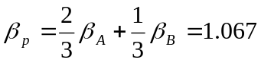

Chapter 13

3. What is the portfolio expected return and the portfolio beta if
you invest 35% in A, 45% in B and 20% in the risk-free asset?

Answer:

Chapter 13

4. You use the single-factor model 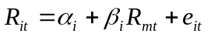 and have obtained the following estimates for stock A and stock B:

Stock  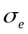
A 2% 1.3 30%
B 10% 1.2 40%

You also estimate that the expected return on the market portfolio is 16%, the standard deviation of the market portfolio is 20%, and the riskless rate is 8%.
a. Based on the single-factor model, what are the expected returns and standard deviations of stock A and stock B?
b. Based on the single-factor model, the Security Market Line, and the Capital Market Line, state whether each of the following statements is completely true, completely false, or uncertain. Explain your answers.
1) In any given year, stock B is certain to outperform stock A.
2) An investor would consider stock B to be riskier than stock A.
3) Stock A is undervalued.
4) If an investor had to select one investment to combine with the riskless asset, the investor would prefer stock A to the market portfolio.
Answer:
a. Based on the information given, the expected returns and the standard deviations using the single-factor model for stock A and stock B are calculated as follows:
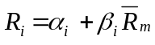
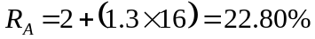
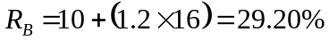

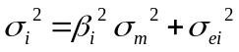

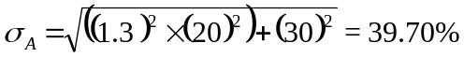
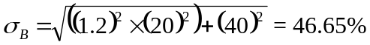

b.
Based on the single-factor model, the expected returns for stocks A and B are 22.8% and 29.2% respectively.

Based on the security market line, the expected return on stocks A and B are:
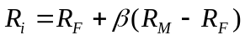

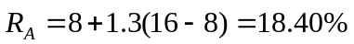

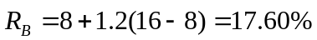

Based on the capital market line, expected return on stocks A and B are:
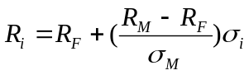

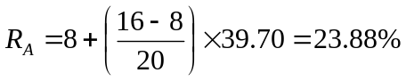

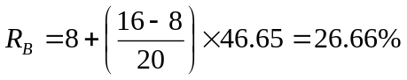

As per single-factor model:
1) False. Both stocks have different unsystematic returns. In the given scenario, the unsystematic returns of stock B is higher than stock A. Therefore, stock B's returns are higher. However, in a given period when stock A has higher unsystematic returns than B, stock A will outperform B.
2) True. Stock B riskier compared to stock B as its standard deviation is higher.
3) False. Rate of return per unit of risk for stock A is lower than market. Therefore, stock A is overvalued.
4) False. Stock A is overvalued as its rate of return per unit of risk is lower. Therefore, an investor will benefit from buying the market portfolio.

As per security market line:
1) False. In the given scenario, stock B returns are lower than that of stock A.
2) False. Stock A riskier compared to stock B as it has a higher Beta.
3) Uncertain. We have computed the expected returns based on the SML equation. However, it is not clearly indicated that the stock lies on the SML line. Therefore, we cannot determine whether stock A is undervalued.
4) Uncertain. As stock A’s returns are positively correlated with the market returns, the answer to this will depend on the amount of risk an investor is willing to take.

As per capital market line:
1) False. Both stocks have different standard deviations. In the given scenario, standard deviation of stock B is higher than stock A. Therefore, stock B's returns are higher. However, in a given period when stock A has higher standard deviation than B, stock A will outperform B.
2) True, stock B has higher risk compared to Stock A as its standard deviation is higher than A.
3) False. Rate of return per unit of risk for stock A is lower than market. Therefore, stock A is overvalued.
4) False. Stock A is overvalued as its rate of return per unit of risk is lower. Therefore, an investor will benefit from buying the market portfolio.
Chapter: 13

5. Consider the following data for assets A and B:
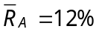; 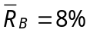; 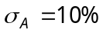; 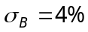; 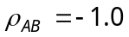
a. If only assets A and B are available, draw the efficient frontier.
b. If the riskless lending and borrowing rate is 10%, why is this a disequilibrium situation and what is the arbitrage that will restore equilibrium?
Answer:
a. If only assets A and B are available, and both the assets have a perfect negative correlation, the standard deviation of the portfolio will plot a straight line. Thus, a review of the return on the portfolio of two assets as a function of the standard deviation will yield two straight lines on the graph. The risk on portfolio of assets is always smaller when the correlation coefficient is -1 than when it is +1. Hence, when two assets A and B are perfectly negatively correlated, it is always possible for a combination of these two assets to have a zero risk. Hence, we can draw an efficient frontier in the following way:

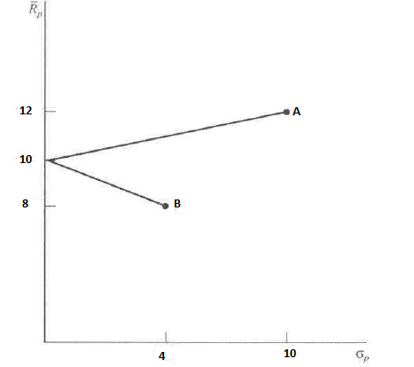

b. According to the CAPM model, the relationship between the expected return on any two assets can be related simply to their difference in Beta. The higher the Beta for any security, the higher must be its equilibrium return. In our situation, introducing a riskless security offering a 10% return induces arbitrage opportunities as there is another risk-bearing security, but with a lower return. In such a case, investors will follow the arbitrage process and start short-selling asset B which offers an 8% return, and start buying the riskfree asset, till the time when both the securities come under equilibrium on the security market line.
Chapter: 13

6. If one accepts the Sharpe single-index model, and the simple form of the CAPM holds, what is 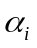(the intercept term in the Sharpe single-index model) equal to?
Answer:
The Sharpe single-index model holds the equation of return on a security to be as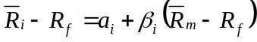. Here, 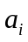represents that component of return which is independent to the return on market. Further, is broken into two parts (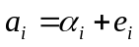), wherein, denotes the expected value of and represents the uncertain amount of , which has an expected value of zero.

As per CAPM, the equilibrium return of a security can be determined using the following equation: 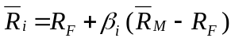.

If we assume that the CAPM holds, we can compare the two equations to determine that 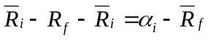. This can be rewritten as 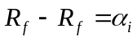 or 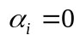.
Chapter: 13

7. Consider the following data for stocks A and B:
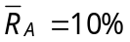; 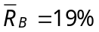; 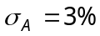; 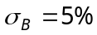; 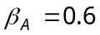; 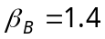; 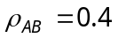
a. Calculate the expected return, variance, and beta of a portfolio constructed by investing 1/3 of your funds in stock A and 2/3 in stock B.
b. If the riskless rate of return were 5%, what percentage of money invested in risky stocks should an investor place in each stock (assuming A and B are the only risky assets available)?
c. If the security market line describes equilibrium, and stocks A and B are in equilibrium, what is the return on the market portfolio and the riskless rate of interest?
d. If an investor can lend and borrow at the riskless rate determined in part c, but is restricted to holding only one of the two risky stocks in this problem, which stock should be held?
Answer:
a. Expected Return:
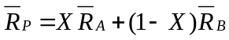

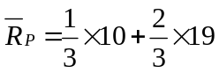

=16%

Beta of the portfolio:
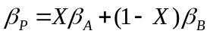

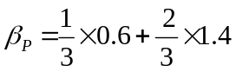

=1.13

Variance of the portfolio:
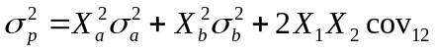

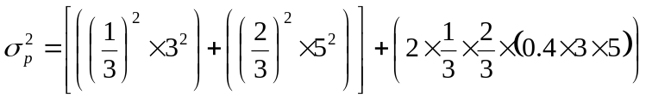

= 14.78%

b. If the riskless rate of return were 5%, the percentage of money invested in risky stocks can be calculated as follows:
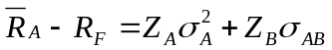

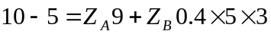

5 = 9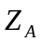+ 6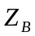…. (1)

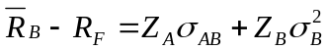

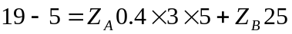

14 = 6+ 25…. (2)

Solving equation (1) and (2), we get,

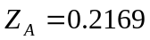 and 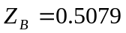

Thus, the proportion to invest in each security is:

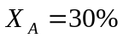 and 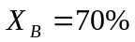

c. The security market line equation for security A is 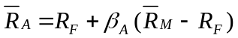 and for security B is 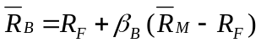. Substituting the values given in the problem, we get, 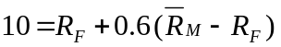 and 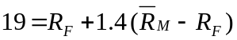.

From the above given equations, we get the value of market premium 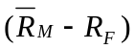of 11.25%. Substituting the value of market premium in the equation, we get the value of risk free rate of return (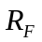) as 3.25% and the return on market portfolio (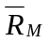) as 14.5%.

d. We can determine the stock to be held by comparing the excess of returns to the risk taken. Excess of returns can be calculated by:
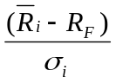
Stock B gives a higher excess return to standard deviation of 3.15, as compared to 2.25 of stock A. Hence, the investor should hold stock B.
Chapter: 13

8. Consider the following data for Dodger Corp. and the S&P 500:

Year Dodger Corp. Price S&P 500 Level
1979 40.00 150.00
1980 36.00 150.00
1981 34.20 145.50
1982 20.52 160.05
1983 22.57 163.25
1984 22.34 159.99

a. What is your estimate of beta for Dodger Corp.?
b. What portion of the firm's total variance is systematic, and what portion is unsystematic?
c. What is the required rate of return for Dodger Corp. if the riskless rate is 7% and the market risk premium is 8%?
Answer:
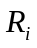= Ending value - Beginning value
Beginning Value
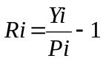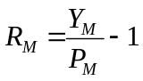
A and the return on market =

a.

Year | Dodger Corp. Price | S&P 500 Level | 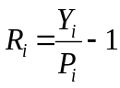 |  | Deviations from Average (Dodger) | Deviations from Average (Market) | Stock Variance | Market Variance | Covariance
1979 | 40 | 150
1980 | 36 | 150 | -10% | 0% | -0.79% | -1.40% | 0.0063% | 0.01961% | 0.01112%
1981 | 34.2 | 145.5 | -5% | -3% | 4.21% | -4.40% | 0.1769% | 0.19364% | -0.18507%
1982 | 20.52 | 160.05 | -40% | 10% | -30.79% | 8.60% | 9.4829% | 0.73952% | -2.64815%
1983 | 22.57 | 163.25 | 10% | 2% | 19.20% | 0.60% | 3.6849% | 0.00359% | 0.11496%
1984 | 22.34 | 159.99 | -1% | -2% | 8.19% | -3.40% | 0.6702% | 0.11542% | -0.27814%
 |  |  |  |  | Average |  | 3.50528% | 0.26795% | -0.74632%

- The estimated Beta of the firm is equal to covariance (stock and market) ÷ market variance. Hence, the Beta is = -2.78534.

b. To find the value of the firm’s systematic and unsystematic variance, we use the following equation:
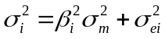

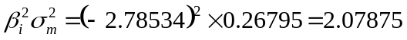

As 2.07875% is the systematic variance, the unsystematic variance can be found by the following equation:
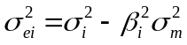

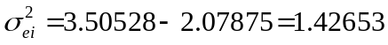

c. The expected rate of return on Dodger’s stock is:
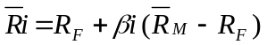
=7% + -2.78534(8%)
=-15.28%
Chapter: 13

9. An efficient portfolio has an expected return of 20%. The riskless rate is 5%, the return on the market portfolio is 15%, and the standard deviation of the market portfolio is 20%. What is the efficient portfolio's beta, standard deviation, and correlation coefficient with the market portfolio?
Answer:
From the given information, we are able to find the following values:

Beta of the efficient portfolio is:
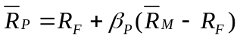

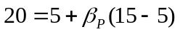

Hence, the security’s Beta is1.5.

For an efficient portfolio, the return on the portfolio can be found using the following equation:
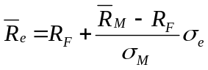

Here, 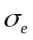 is the standard deviation of the efficient portfolio.
Hence, 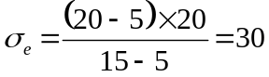

To determine the correlation coefficient, we use the following formula:
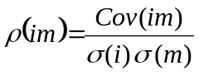

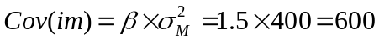
Hence,
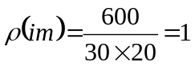
Chapter: 13

10. You believe that Beta Alpha Watch Company will be worth $100 per share one year from now. How much are you willing to pay for one share today if the riskless rate is 8%, the expected return on the market is 18%, and the company's beta is 2?
Answer:
As the riskless rate, expected rate of return on market, and the company’s beta have been provided, we can calculate the expected return on the firm’s security.
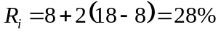

We have been given the share price one year from now as $100.
Based on the security’s rate of return, we calculate a present value per share to be $78.125 [$100/(1+0.28)¹].
Chapter: 13

11. Consider the following data:

ABC XYZ Market
Price $20 $50 -
Dividend $0.40 $2 6%
Beta 1.5 1.0 1.0
Alpha -1.0% 2.0% -

The riskless rate is 10%, and the expected return on the market is 20%. Your portfolio consists of 50,000 shares of ABC and 10,000 shares of XYZ.
a. Give the values of the following statistics for your portfolio: dividend yield; expected prices for ABC and XYZ in one year; beta; and alpha.
b. Suppose you are in the 40% effective marginal tax bracket and you plan to hold your portfolio more than one year. What is the expected after-tax return on your portfolio? What is the expected after-tax return on the market portfolio?
Answer:
a.
Dividend yield = | Dividend for period
Dividend yield = | Initial price for the period

Dividend yield of ABC stock is = 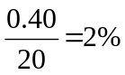
And, dividend yield of XYZ stock is = 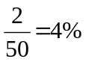
Hence, dividend yield on the portfolio = 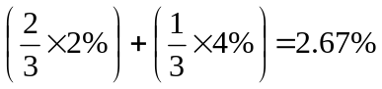

Expected prices for ABC and XYZ in one year can be determined as follows:

The expected return on ABC shares is:
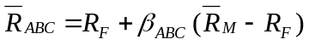

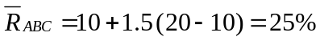
Assuming expected price as X, we get the following equation:
((X - 20) + 2)/20 = 0.25
Solving the equation, we get the expected price of ABC shares one year from now as $23.

Similarly, we can determine expected price of XYZ shares as:
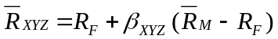

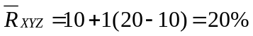

The expected price of the share XYZ is:
((X - 50) + 2)/20 = 0.20
Hence, the expected price of the share XYZ = $58

Also, the return on the total portfolio is determined as:
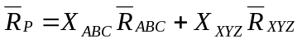

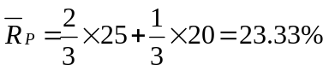

Beta of the portfolio:
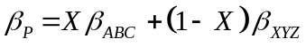

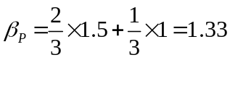
Alpha of the portfolio:
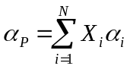

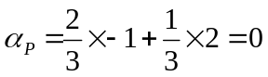

b. The expected after-tax return on a portfolio is:

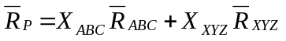

Hence, the after tax return on investor’s portfolio =
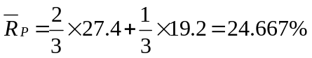
The expected after tax return on market portfolio=
Therefore, the expected after tax return on market portfolio will remain 20%
Chapter: 14

12. The expected return on the market portfolio is 20% and the riskless rate is 10%. XYZ gold mining has a beta of -0.2. What is the expected return on a short sale of 100 shares of XYZ, assuming you can get the proceeds of your short sale? What if you can't?
Answer:
The expected return on stock XYZ will be determined as follows:
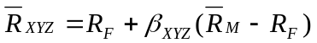
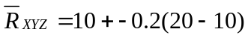
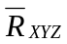= 8%.

The expected return on the security XYZ is lower than both the market portfolio and the riskless rate of return. If an investor gets the proceeds from short selling 100 shares of security XYZ, he can either invest in the market portfolio or at the riskless rate of return to benefit from the short sale.

If the investor invests the proceeds in the market portfolio, the expected return would be 20%. Thus, the effective return from a short sale would be 12% (20% - 8%).

If the investor invests the proceeds in the risk free asset, the expected return would be 10%. Thus, the effective return from a short sale would be 2% (10% - 8%).

However, if the proceeds cannot be received, the return on the short sale will solely depend on price movement. If all expectations actualize, the effective return in this case will be -8%.
Chapter: 13

13. Consider the following data for funds A, B, C, and D:
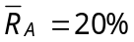; 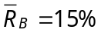; 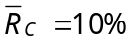; 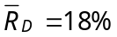; 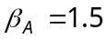; 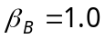; 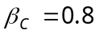; 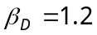.

Assume that the zero-beta form of the CAPM is a reasonable description of reality and that funds A and B are accurately priced. Which funds' returns are not in equilibrium and by how much? What is the arbitrage that would restore equilibrium?
Answer:
Assuming the zero-beta model, we get the rates of riskfree assets and the market premium with the help of the equation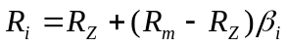. Substituting the values of both the securities A and B in equilibrium, we get the value of 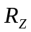 as 5% and market premium as 10%.

On the basis of these values, we get the expected return on stock C under equilibrium as:
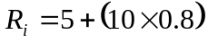=13%. The return on stock C currently is 10%.
Similarly, we calculate the expected return on stock D by 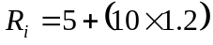 =17%. The current rate of return on stock D is 18%.
Security C is expected to provide a higher return than the current projections, whereas to Security D is expected to provide a lower return than the current projections. Therefore, to restore the equilibrium, investors must hold a long position in D and a short position in C.
Chapter: 14

14. Plot the standard CAPM and the zero-beta CAPM on the same diagram. Be sure to label all points.
Answer:
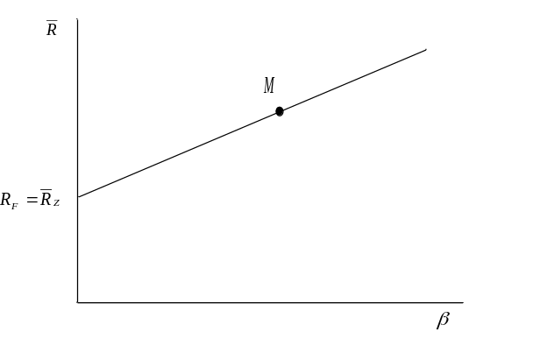

M is the market portfolio having a Beta of 1. In case of a simple CAPM, is the point where the security market line cuts the vertical axis (where Beta equals zero). In case of a zero-beta CAPM, the riskless lending or borrowing activity is discontinued. 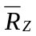is assumed to be the intersection of the vertical axis and the zero-Beta capital asset pricing line. Hence, the point which intersects the vertical line in both the models is the same and has a Beta of zero.
Chapter: 14

15. Consider the following data for securities A and B:
; 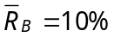; ; 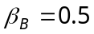.

Assume that the zero-beta CAPM holds and that all securities are in equilibrium. Plot the Security Market Line. Be sure to label all points.
Answer:
To develop a security market line where the zero-beta CAPM holds and all securities are in equilibrium, all securities contained in (the market portfolio) must have an expected return given by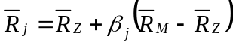. All portfolios composed solely of risky assets have returns from the above mentioned equation. The line 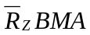is the line that defines the equation. This equation holds only for risky assets and for portfolios of risky assets.

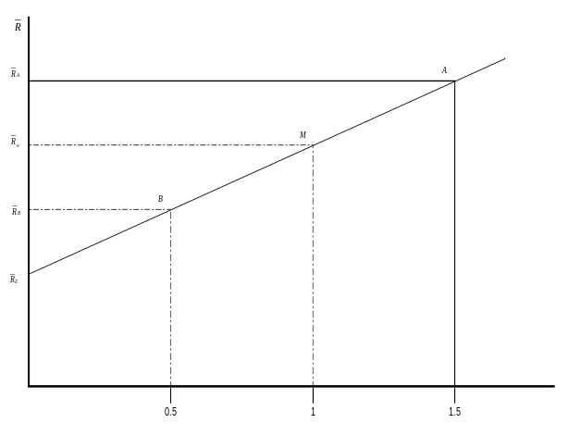
Chapter: 14

Essays

1. Discuss the two mutual fund theorem. Show why it arises. (A diagram may help.)
Answer:
For investors to hold a very well diversified portfolio, they will have to perform riskless borrowing and lending as well as invest in risky assets.
If all investors have consistent expectations of lending and borrowing and they face the same lending and borrowing rate, then they will face a situation, wherein portfolio of risky assets,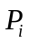, held by one investor will be identical to the portfolio of risky assets held by any other investor. If all investors hold the same risky portfolio, then, in equilibrium, it must be the market portfolio. The market portfolio is a portfolio that comprises all risky assets available. The proportion of each asset held in an investor's portfolio is same as the proportion represented by the market value of the asset as compared to total market value of all risky assets.
The portfolio of risky assets that any investor holds can be identified without regard to the investor’s risk preferences. This portfolio lies at the tangency point between the original efficient frontier of risky assets and a ray passing through the riskless return. This can be depicted from the diagram shown below. This is depicted in the diagram where 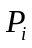denotes investor (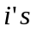) portfolio of risky assets. The investors satisfy their risk preferences by combining portfolio with riskless lending or borrowing. Hence, all investors will hold a portfolio along the line connecting 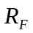with in the expected return standard deviation spaces as depicted in the following figure:
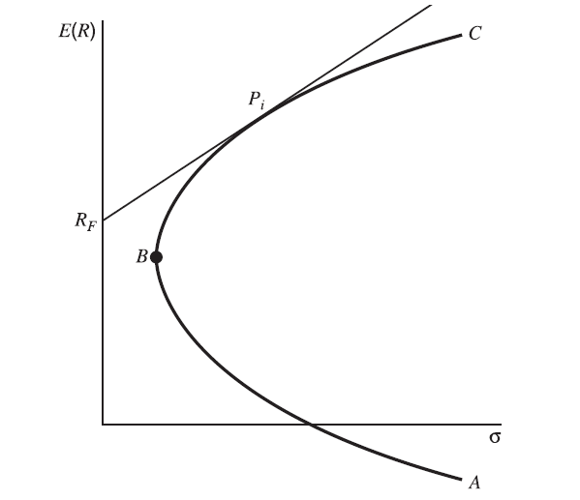

Thus, the two mutual fund theorem states that all investors can construct an optimum portfolio by combining a market fund with riskless lending or borrowing.
Chapter: 13

2. You have been hired as a consultant to advise a client on an appropriate measure of risk to use in judging the client's stock investments. What do you tell your client and why?
Answer:
Risk is the uncertainty of returns, or more specifically, the probability of loss on any investment. Standard deviation and beta are two of the most commonly used variables to measure risk. While standard deviation measures the historical volatility in the returns of an asset, beta is more specific, and reflects the returns affected by the over-all movement of the markets.

If the client’s portfolio is relatively diversified, majority of the risk in the portfolio will be systematic (since diversification will minimize unsystematic risk). A good measure of risk in this case would be to check for the excess returns over a benchmark, typically a risk-free rate, generated for each unit of market risk (beta). Beta being the index of systematic risk, the expected return on any two assets can be related to their difference in Beta. The higher the Beta, the higher is the return on securities.

On the contrary, if the portfolio is concentrated, use of standard deviation to calculate excess returns per unit of risk would give a better picture, since standard deviation also captures the stock specific (unsystematic) risk in the portfolio.

Chapter: 13

3. Explain the essential features of the following three lines: the Security Market Line, and the Capital Market Line. How is each used in discussions of security price behavior? Suppose you know that portfolio P is an efficient portfolio. What does this tell you about its position with respect to each of the lines?
Answer:
Capital Market Line: All investors hold combinations of two portfolios. They are the risky assets in the market portfolio and a riskless security which are depicted using a single line. This has been explained with the help of a diagram given below:

The straight line in the diagram is called the Capital Market Line (CML). All efficient portfolios lie along the capital market line. However, not all securities or portfolios lie along the capital market line. In fact, all portfolios of risky and riskless assets, except those that are efficient, lie below the capital market line.
By analyzing the CML, we can learn about a portfolio’s market price of risk through the equation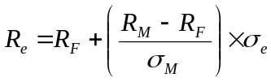. Here, the market price of risk for all efficient portfolios is denoted by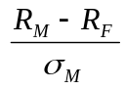. It is the extra return that can be gained by increasing the level of risk (standard deviation) on an efficient portfolio by one unit. The expected return on an efficient portfolio is: Expected return = Price of time + (Price of risk × Amount of risk).

Hence, a portfolio P, which is an efficient portfolio, will lie at the tangency point between the original efficient frontier of risky assets and a ray passing through the riskless return on the vertical axis along the Capital Market Line.

Security Market Line: In a graph, where the points of market portfolio (M) with a Beta of 1 and an intercept with a Beta of 0 are given, and when a line passes through both the points, the line is called the Security Market Line (SML). The SML describes the expected return for all assets and portfolios of assets in the economy. The expected return on any asset, or portfolio, whether it is efficient or not, can be determined from the equation 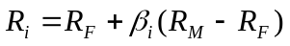 of SML. The relationship between the expected return on any two assets can be related simply to their difference in Beta.

The higher Beta is for any security, the higher must be its equilibrium return. Furthermore, the relationship between Beta and expected return is linear. The expected return on any security is the riskless rate of interest plus the market price of risk times the amount of risk in the security or portfolio.

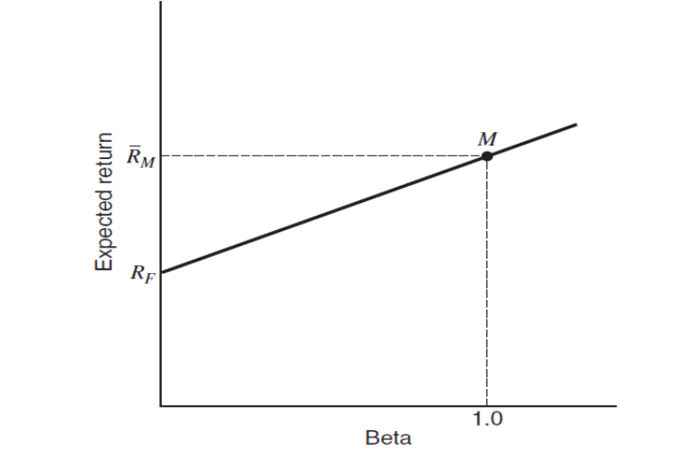
It takes only two points to identify the security market line. Point M with a Beta of 1 and an expected return of 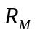 represents the market portfolio. The second point is the intercept that occurs when the Beta is zero represented by . Therefore, if we assume that portfolio P is efficient, it will lie along the straight line M and .
Chapter: 13

4. Explain how the zero Beta version of CAPM is derived.
Answer:
The second assumption of the CAPM is that investors can lend and borrow unlimited sums of money at the riskless rate of interest. In the absence of such a situation, which is more representative of the real world, an alternative capital asset pricing model is required.
The systematic risk (Beta) of a portfolio is an appropriate measure of risk in case of a large diversified portfolio. This is because the unsystematic risk of a large diversified portfolio is essentially zero. Thus, even if an individual asset had a great deal of unsystematic risk, it would have little impact on portfolio risk and, therefore, unsystematic risk would not require a higher return.

If securities or portfolios happen to lie on a straight line in expected return Beta space, all combinations of securities or portfolios would lie on the straight line. A straight line can be described by any two points. One convenient point is the market portfolio with a Beta of 1. The second convenient point is where the straight line cuts the vertical axis, where the Beta equals zero. The equation of the straight line is:
Expected return = 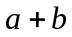(Beta)
For a portfolio with zero Beta, letting 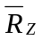be the expected return on a portfolio, we get,
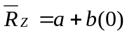 or 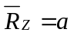
The equation must also hold for the market portfolio. If 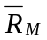 is the expected return on the market and, recalling that the Beta for the market portfolio is one, we have
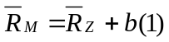 or 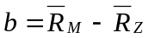.
Putting the two equations together and letting 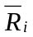 be the expected return and 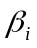 be the Beta on an asset or portfolio, the equation for the expected return on any security or portfolio becomes:
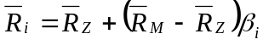
This is called the zero-Beta version of CAPM where there is no riskless lending or borrowing. A graph depicting this model is plotted below.

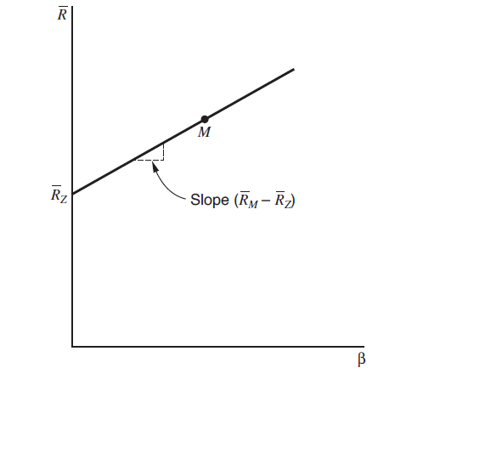
Chapter: 14

5. Discuss possible bias inherent in estimating the true Beta value according to Lintner and Douglas. What are the findings of Miller and Scholes on the basis of this evaluation?
Answer:
According to Miller and Scholes, during the CAPM equation estimation, if returns are really generated by the simple form of the CAPM, then the time series equation used to estimate Beta should be consistent with the CAPM. The CAPM in time series form is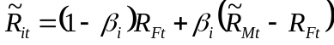. But the market model equation for the CAPM used by Lintner and Douglas is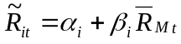. If is a constant over the estimation period, it is not a problem. The estimate of should be equal to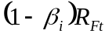. However, if 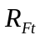 fluctuates over time and if it is correlated with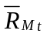, there will be a case of missing variable bias and 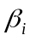 will be a biased estimate of the true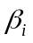.

Miller and Scholes prove that if 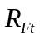 and 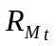 are negatively correlated, then this will have the effect of biasing the intercept of the second-pass regression upward and its slope downward and this could, in part, explain the inconsistencies found by Lintner and Douglas. Miller and Scholes examine historical data and find a negative correlation. This is not surprising, for the stock market usually declines when interest rates go up. They test for the importance of this in explaining the Lintner findings.

Although they find the influence is in the correct direction, the order of magnitude of the bias is so small that it would have negligible effects on the results.
Chapter: 15

6. Consider the following multi-index model: 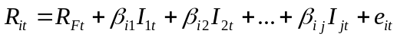 where:
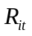 is the return on asset i in period t
is the risk-free rate in period
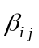 is the sensitivity of asset to factor
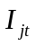 is the value of factor in period
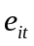 is a random error term for asset in period

a. Assuming the APT holds, what is the expression for the expected return of asset i?
b. How can the APT be used in decision making?
c. Outline, in list form, the assumptions underlying the APT.
Answer:
Arbitrage pricing theory (APT) is a new and different approach to determining asset prices. It is based on the law of one price which means that two items that are the same can’t sell at different prices.

From APT model, we can derive that pricing can be affected by influences beyond simple averages and variances.

a. A two-index model describes returns as: 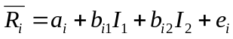. The only terms in the equation that affect the systematic risk in a portfolio are 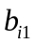 and 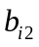, as the residual risk tends to be zero.

The general equation of a plane, where all the investments and portfolios lie, in expected return,, and space, for a well diversified portfolio is: 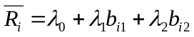. 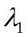is the increase in expected return for a one-unit increase in .Thus and 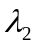 are returns for bearing the risks associated with and 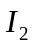for each unit of and respectively.

If we assume a portfolio with and both equal to zero, the expected return on this portfolio equals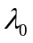. This is a zero-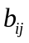 portfolio, and we denote its return as.
Substituting for and examining a portfolio with a of zero and a of one, we
see that, 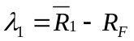. Here, 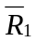is the return on a portfolio having a of one and a of zero. In general, 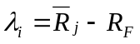or 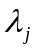is the expected excess return on a portfolio only subject to risk of index and having a unit measure of this risk.

The analysis in this section can be generalized to the index case as:
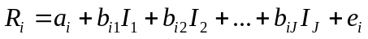
By such analogous arguments it can be shown that all securities and portfolios have expected returns described by the APT model:
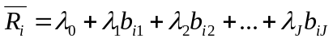.

b. The APT model, allows us to recognize the importance of multiple factors in determining the expected excess return on a specific index, any specific security, or a portfolio. APT, if implemented properly, could be a useful tool in determining the factors other than market which affect the price of the security. This model can also be used to explain relative prices of different securities operating in the same industry and markets.

With respect to portfolio management, this model can help managers decompose the factors affecting the returns of the securities to identify mispriced securities. Passive managers believe that mispriced securities can’t be identified and thus try to hold a portfolio that mimics some set of stocks. The most common way passive management is practiced is to hold a portfolio of stocks that closely tracks a selected index. Active management, on the contrary, involves making bets about some securities or set of securities in the sense of designing a portfolio based on a belief that one or more securities are mispriced.

c. Assumptions underlying the APT are as follows:

- APT holds the assumption of homogeneous expectations.
- The assumption of process generating security returns is followed in this model.
- The APT also requires that the returns on any stock to be linearly related to a set of indexes.
Chapter: 16

7. List set of equity and fixed income factors that were shown to have generated historical premia. Define the value factor and its economic interpretation.

Answer
The following are the factors:
- Term Structure Factor
- Credit Risk Factor
- Foreign Exchange Carry
- Value Factor
- Size Factor
- Momentum Factor
- Volatility Factor
- Liquidity Factor
- Inflation Factor
- GDP Factor
- Equity Risk Premium Factor

Value factor is constructed from a long position in stocks with a high book-to-market ratio and a short position in stocks with an unusually low book-to-market ratio. One economic interpretation of the value factor is that it represents compensation for firm distress, since high book-to-market value reflect low market price. Other economic interpretations are that it compensates for low growth opportunities by inflexible firms with assets in place during periods of distress or time varying sensitivities of value stocks that manifest themselves as changing betas in macroeconomic states. The behavioral explanation for the value premium is over extrapolation of past growth rates into the future.
Chapter 16

